**Challenge 9**

[www.pythonchallenge.com/pc/return/good.html](http://www.pythonchallenge.com/pc/return/good.html)

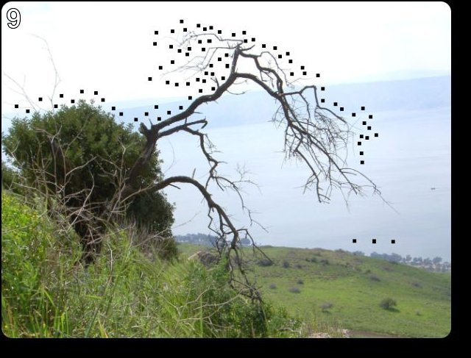  
  
This picture show dots and the title is ‘connect the dots’. So I pulled it up in pcpaint and drew lines between the dots but it didn’t look like anything.

I the page source there is some data first + second:

First: 146,399,163,403,170,393,169,391,166. . .

Second: some more numbers, . . .

I tried a few things drawing on a blank canvas. I got some interesting pictures but nothing useful. Finally, cheated and learned that first is one bunch of lines to draw and second is another represented by taking each pair in each list (x, y), e.g., for the first image draw a line from (146,399) to (163,403)

This draws something that looks like a cow with the face outlined. So, try …cow.html. this is an ok url but gives message: hmm. It’s a male. So, try . . . bull.html and this goes to next challenge.